NAME: SOWGANDHIGA.S

ROLL.NO: CB.SC.I5DAS21058

END SEMESTER LAB

1.

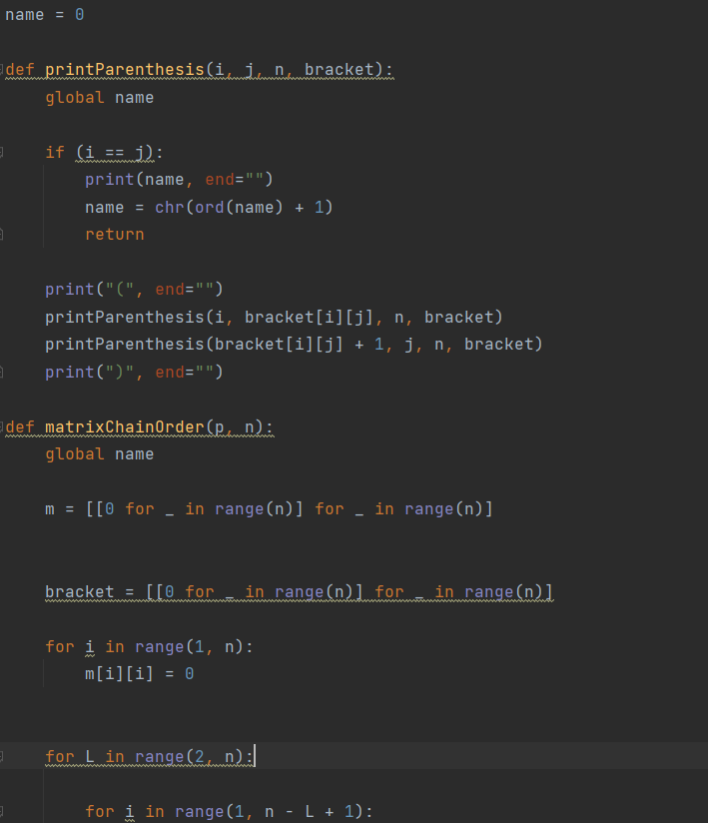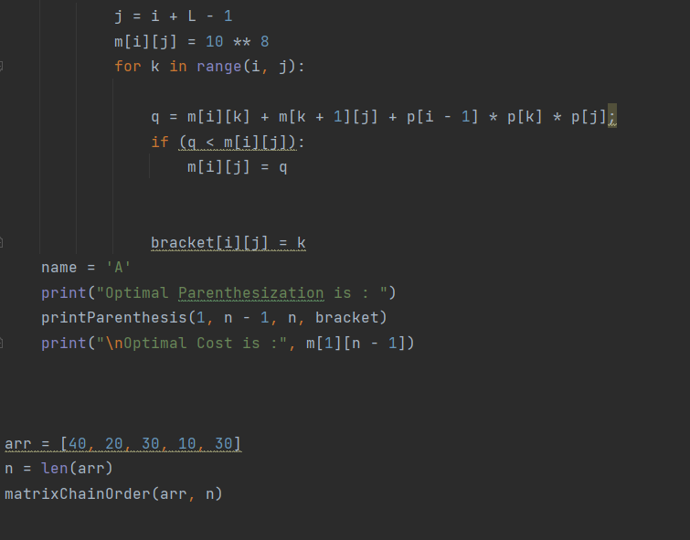

OUTPUT:

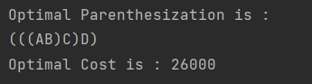

2.

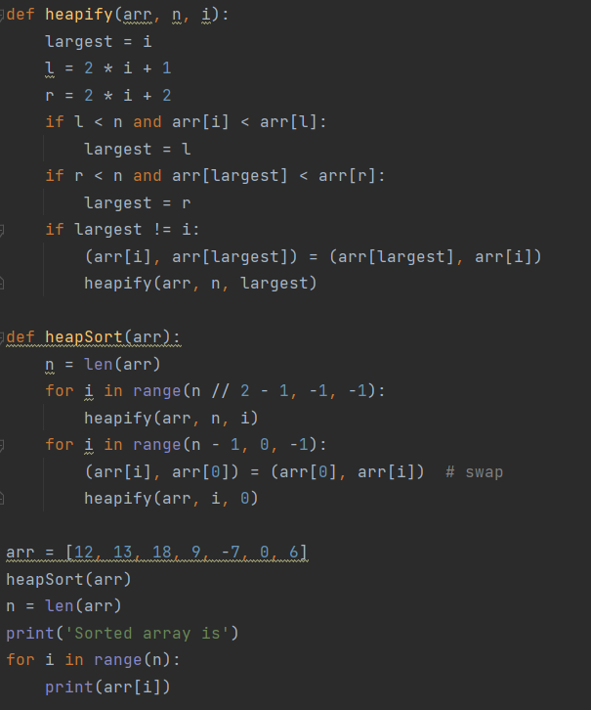

OUTPUT:

